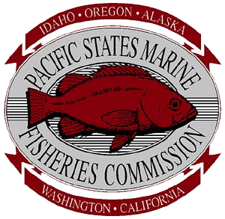

Watercraft Inspection and Decontamination
(WIT III) Trainer Training Course

The Pacific States Marine Fisheries Commission and its 100th Meridian Initiative partners are announcing and sponsoring Watercraft Inspection and Decontamination Trainer Training (WIT III).

PRE-REGISTRATION is Open for Trainer Training Course:
- April 21-23 - Lake Powell

This course is appropriate for state and federal AIS Coordinators, and WID Site Supervisors, including local/state/federal governments, marinas and concessionaires.

To be eligible for the trainer course, an individual must have:

- Passed the Inspection and Decontamination (WIT II) - Version 2 – February 2016
  - Documentation provided by trainer
- Performed a minimum of 50 inspections and at least 5 decontaminations per UMPS III prior to attending a Trainer's course.
- Operated and maintained a decontamination unit that meet’s UMPS III specifications.
- Complete the WIT III Pre-Training survey.

It is Recommended that Supervisor submit a letter of recommendation for consideration if employed less than 3 Seasons and/or verification of WIT II Completion.

To be considered a Trainer you must:
- Complete the AIS trainer's course (WIT III).
- Receive a passing score of 80% on the final exam and demonstrate ability to effectively teach this course in both classroom and practical sessions.
- PSMFC reserves the right to refuse or withdraw trainer certification to those that do not meet expectations
Additional considerations include:
- Hosting a WIT II – If capacity exists for mentoring, it is recommended that ALL new trainers co-teach a minimum of two (WIT II) Inspection and Decontamination courses prior to teaching alone, and that they be evaluated by an experienced trainer prior to teaching independently.
Trainers will be expected to:
- Teach the current procedures according to the Trainer’s Manual
- Be very familiar with training materials
  - Student Manual
  - UMPS III
  - Tahoe Boat Book
  - Colorado Boat Compendium
- Ensure all training prep work is completed in advance of training.
- Report and document trainings of attendee’s and certification levels.
If you would like to be considered for the course, complete the WIT III Pre-training Survey.
For more information, go to: Level 3 Trainer Training or,
contact “Quagga D” to be considered for this exclusive opportunity!
QuaggaDee@cox.net
(702) 236-3814

